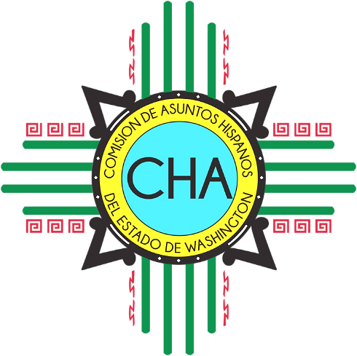
CHA Meeting
Connect Workplace
8350 W Grandridge Blvd 200, Kennewick

Saturday, September 8th
8:30 a.m. Coffee and Mingling (Lounge)

9:00 a.m. Welcome
Commissioner introductions and why CHA?
Staff introductions and why CHA?
Ice-Breaker

9:30 a.m. Recap from June retreat

10:00 a.m. Commissioner Updates

10:45a.m. Executive Director’s Update
- Outreach and Engagement
- Operations
- Budget
- Staffing

11:15 a.m. Review and vote on minutes

11:45 a.m. Review Commission Applications

12:30 p.m. Lunch and down time

1:00 p.m. Review and vote on 2019 Priorities and Strategy
- Outreach and Engagement
- Advocacy
- Legislative

2:00 p.m. L&I

2:30 p.m. End

