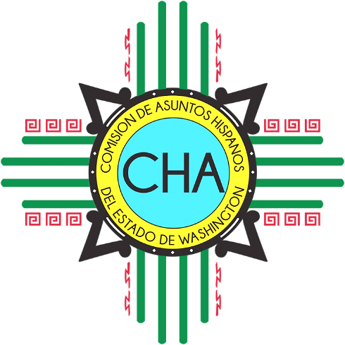
CHA Monthly Conference Call
Skype: Join Skype Meeting
(360) 407-3854; Code: 4290239

Friday, January 11, 2018
10:00 AM- 11:00 AM

- Roll Call

- Guest Introductions

- Overview of Agenda

- Chair and Vice-Chair Updates

- Commissioner Updates

- Executive Director Updates

- Special Projects and Ops Manager Updates

- Guest Speaking Time

  - Up to 2 minutes each person

