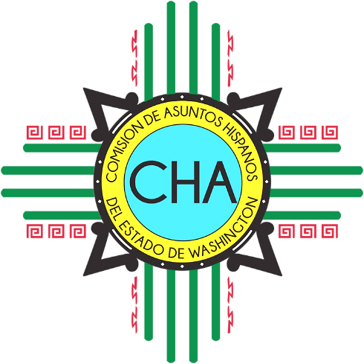
CHA Monthly Conference Call
Skype: Join Skype Meeting
(360) 407-3854; Code: 4290239

Friday, February 8th, 2018
10:00 AM- 11:00 AM

- Roll Call

- Overview of Agenda

- Chair and Vice-Chair General/Legislative Updates

- Commissioner General/Legislative Updates

- Executive Director General/Legislative Updates

- Special Projects and Ops Manager Updates

