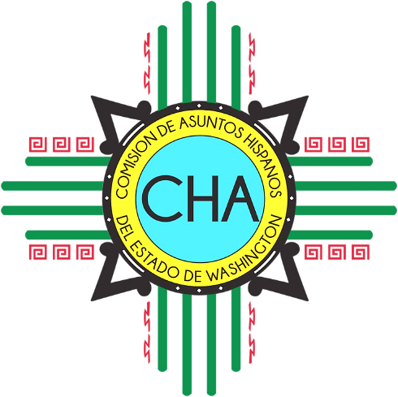
CHA Monthly Conference Call
Skype: Join Skype Meeting
(360) 407-3854; Code: 4290239

Friday, March 22nd, 2019
10:00 AM- 11:00 AM

- Roll Call

- Legislative Updates
  - Chair and Vice-Chair
  - Commissioners
  - ED

- Latino Legislative Day: recap

- Adjourn

