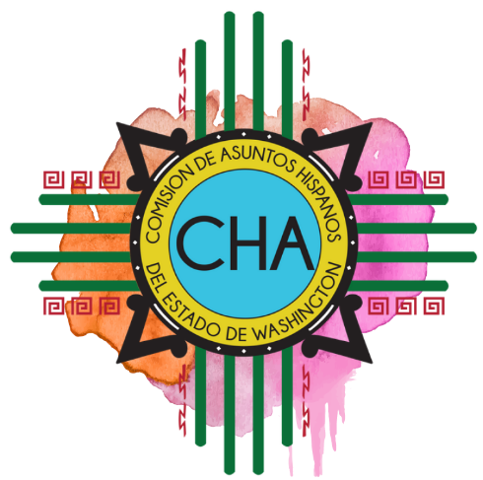
Commission on Hispanic Affairs
3rd Quarter Commission Meeting
Henry Beauchamp Community Center
1211 7th St
Yakima, WA 98901

Saturday, September 7th

8:30-8:45 a.m. Coffee and Mingling

8:45-9:15 a.m. Call to Order
Review Agenda
Hello/Ice Breaker

9:15-9:45 a.m. Activating Existing Channels

9:45-10:30 a.m. Collaborative Opportunities

10:30-10:45 a.m. Break

10:45-11:15 a.m. Business: Approval of Minutes
- June 2019 in-person
- July Conference Call
- August Conference Call

11:15-11:45 a.m Staff Updates
- Communications
- Operations

11:45 a.m.-12:30 p.m. LUNCH

12:30 p.m. Open House

1:00 p.m. Bishop

1:30 p.m. Census Presentation

2:00 p.m. Awards

2:10 p.m. Community Forum

3:00 p.m Adjourn

