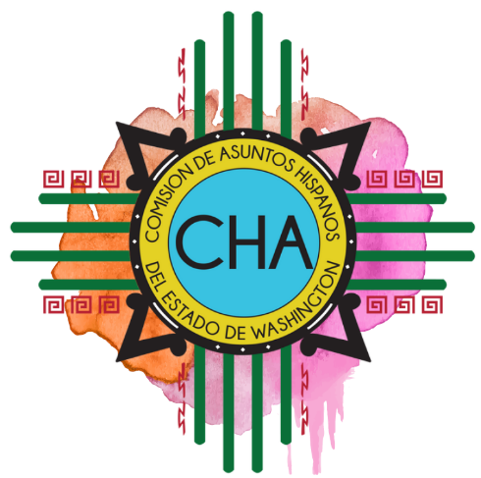
Commission on Hispanic Affairs
2nd Quarter Commission Meeting
Snohomish County Campus
Public Meeting Rooms 1 & 2
3000 Rockefeller Ave
Everett, WA 98209

Saturday, June 8th

8:30-8:50 a.m. Registration and Coffee

9:00 a.m. Community Forum Welcome
Julieta Altamirano-Crosby

9:05-9:20 a.m. Commissioner Introductions

9:20- 9:45 a.m. CHA Presentation, Q&A
Maria Siguenza

9: 45-10:10 a.m. Community Member Introductions

10:10-10:20 a.m. Award
Julieta Altamirano-Crosby and Maria Siguenza

10:20-11:00 a.m. Presentation
Sr. Ángel, Subsecretario del Migrante Internacional de Guanajuato

11:00-11:10 a.m. Break

11:10 a.m. Community Forum

11:50 a.m. Adjourn

12:00 p.m. Lunch
Call to Order
Review Agenda
Collaborative Opportunities

1:15 p.m. Employment Security Department
Paid Family Leave Act
Silvia Lugo

1:30 p.m. Business: Approval of Minutes
- March 2019 in-person
- March Conference Call
- April Conference Call
- May Conference Call

2:00 p.m. Commissioner Influence and Engagement Model

2:30 p.m. Strategic Plan and Report Out Structure

3:00 p.m Adjourn

